
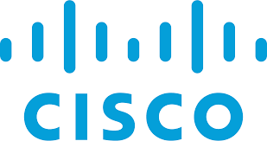
Windows 11 & Applications Installation
Gio Hua – Period 0-2 CCNP

September 9, 2025
CIsco Corporation

Purpose: Learn to install Windows 11 off a flash drive. Additionally, downloading the appropriate drivers (Nvidia & Lenovo), along with applications such as Office 365, PuTTY, and Wireshark
Background: An operating system (OS) is system software that manages computer hardware and software resources and provides common services for computer programs. Time-sharing operating systems schedule tasks for efficient use of the system and may also include accounting software for cost allocation of processor time, mass storage, peripherals, and other resources. For hardware functions such as input and output and memory allocation, the operating system acts as an intermediary between programs and the computer hardware, although the application code is usually executed directly by the hardware and frequently makes system calls to an OS function or is interrupted by it. The current lab requires the user to install Windows 11, an OS produced by Microsoft Corporation. Windows 11 is the most recent OS developed by Microsoft, although Windows 10 is still in use. Microsoft Corporation is an American multinational corporation and technology conglomerate headquartered in Redmond, Washington. Founded in 1975 by Bill Gates and Paul Allen, the company rose to dominate the personal computer operating system market. From 1980 to 2021, it has released 9 versions of MS-DOS (Microsoft Disk Operating System). Once installed, the user should download drivers through Nvidia and Lenovo, along with other applications for future use. Nvidia is a company which designs and sells GPUs (Graphical Processing Unit) for gaming, cryptocurrency mining, and professional applications. On the other hand, Lenovo is a global technology company, originally from China, that designs, manufactures, and sells a wide range of products including laptops, desktops, tablets, smartphones, and other devices. To simulate a network, installation of the application PuTTY is required. PuTTY was originally created by British programmer Simon Tatham in the late 1990s and was first released in 1999 as a multi-protocol terminal emulator for Windows. It is now an open-source project developed and supported by volunteers. PuTTY enables the implementation of SSH and Telnet for Windows and Unix platforms. Similarly, Wireshark is recommended for its monitoring capabilities. Wireshark is a powerful, open-source network protocol analyzer that allows users to capture and interactively browse the traffic running on a computer network, providing deep inspection of hundreds of protocols. In the late 1990s, Gerald Combs, a computer science graduate of the University of Missouri–Kansas City, was working for a small Internet service provider, Network Integration Services. The commercial protocol analysis products at the time were priced around $1500 and did not run on the company's primary platforms (Solaris and Linux), so Gerald began writing Ethereal and released the first version around 1998. Ethereal was renamed Wireshark in May 2006 due to trademark issues. Computer and display customization is available.

Lab Summary: Windows 11 was installed through plugging in a flash drive, then selecting through different choices of configuration. After, applications were downloaded through the web browser and Microsoft app store. These applications included Microsoft Teams, Office 365, Firefox, PuTTy, and Wireshark. Drivers were installed by downloading the Nvidia Control Panel (NCP), along with the Lenovo Commercial Vantage. Through NCP, info regarding the graphics card could be checked, and the latest driver could be installed online. Updates were done on Vantage.
Configurations:
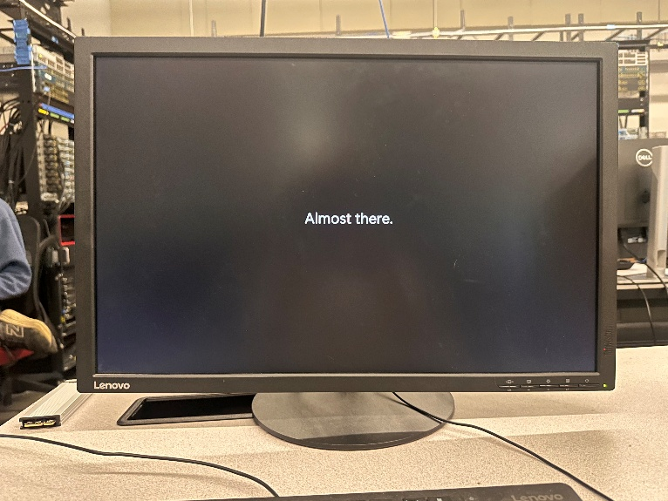
Installing Windows 11:
Step 1: Use a flash drive for Windows Installation and a hard drive to install on
Step 2: insert the drive into the target PC, restart the PC and boot
Step 2: follow the on-screen instructions to select your language
Step 3: install Windows and choose your edition
Step 4: accept the license terms
Step 5: select a drive for installation
Step 6: complete the initial setup process

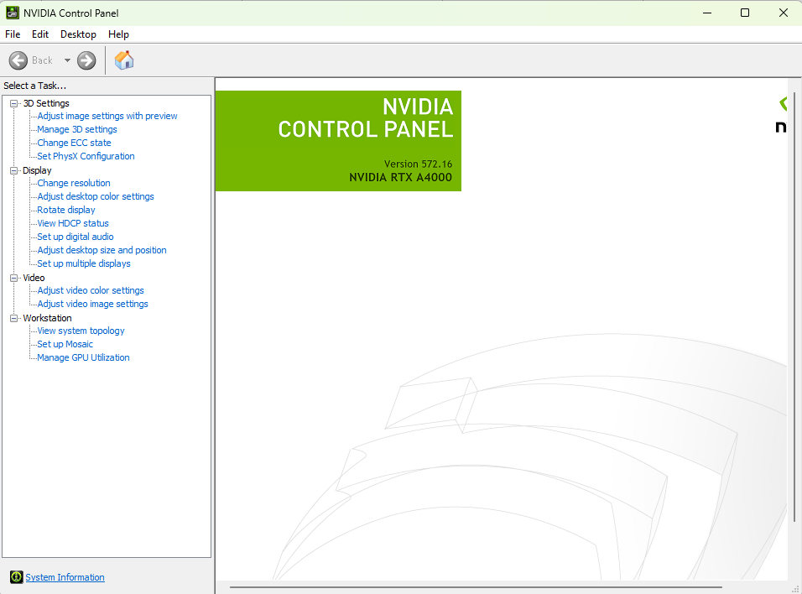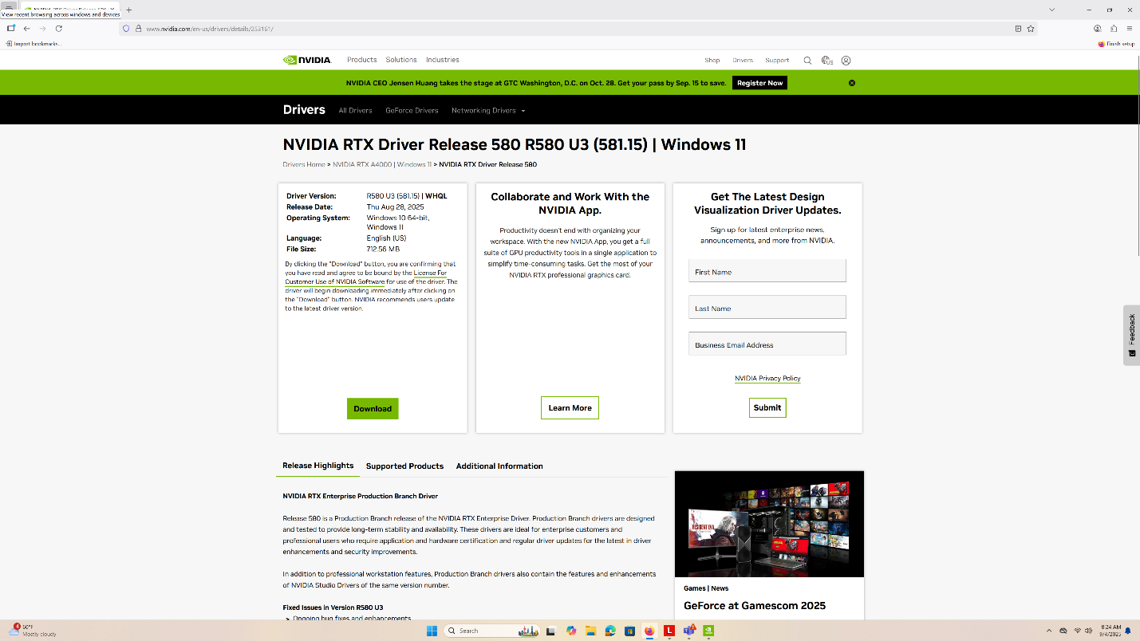
Graphics Card Info – Driver Installation
Step 1: Install NVIDIA Control Panel through Microsoft Store
Step 2: Find your GPU’s model name
Step 3: Go on https://www.nvidia.com/en-us/drivers/ and look up the model name
Step 4: Download the latest driver

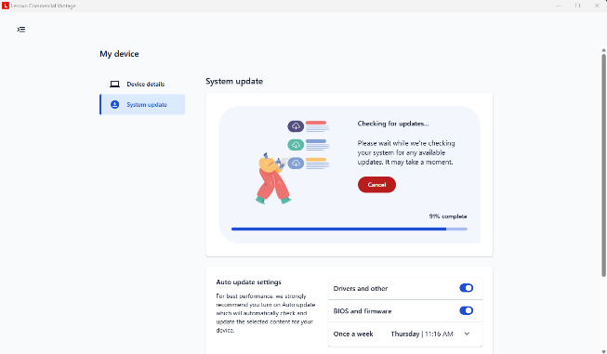
Lenovo Updates – Driver Installation
Step 1: Download Lenovo Commercial Vantage from the Microsoft Store
Step 2: Go to System update tab
Step 3: Update your system

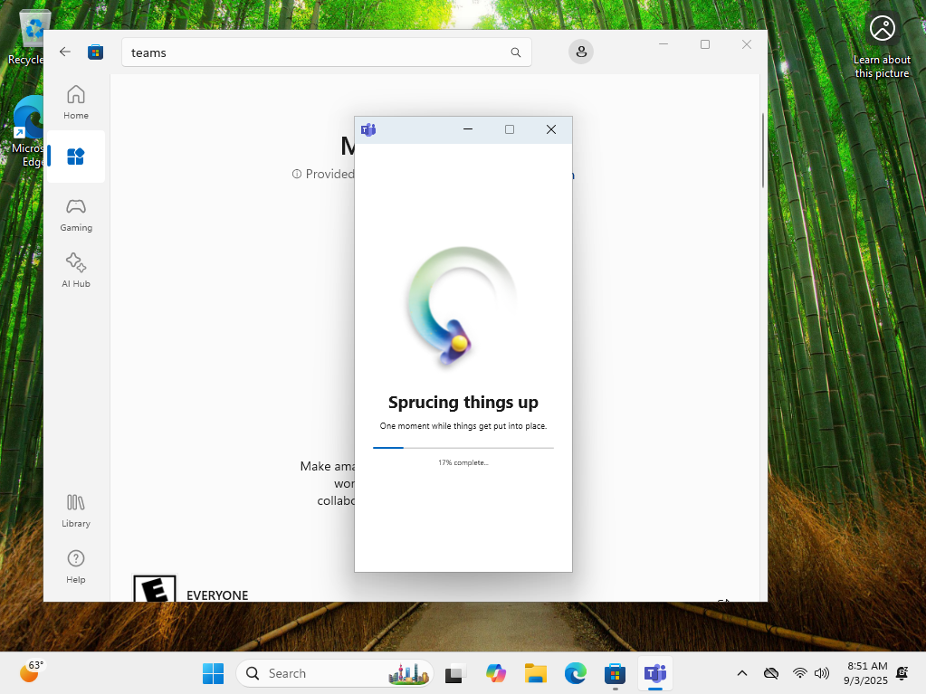
Teams – Downloading Applications
Step 1: Download teams off Microsoft Store
Step 2: Sign in

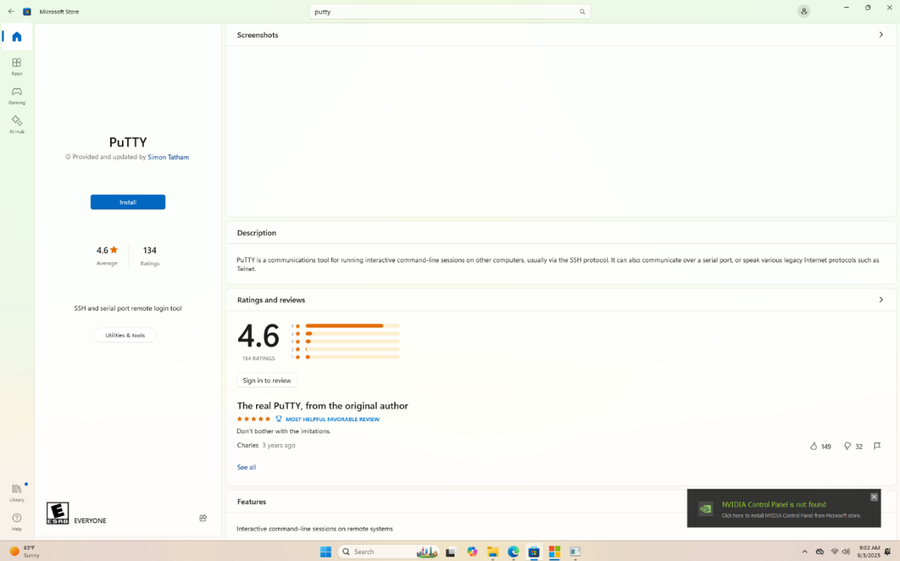
PuTTY – Downloading Applications
Step 1: Download Putty from Microsoft store

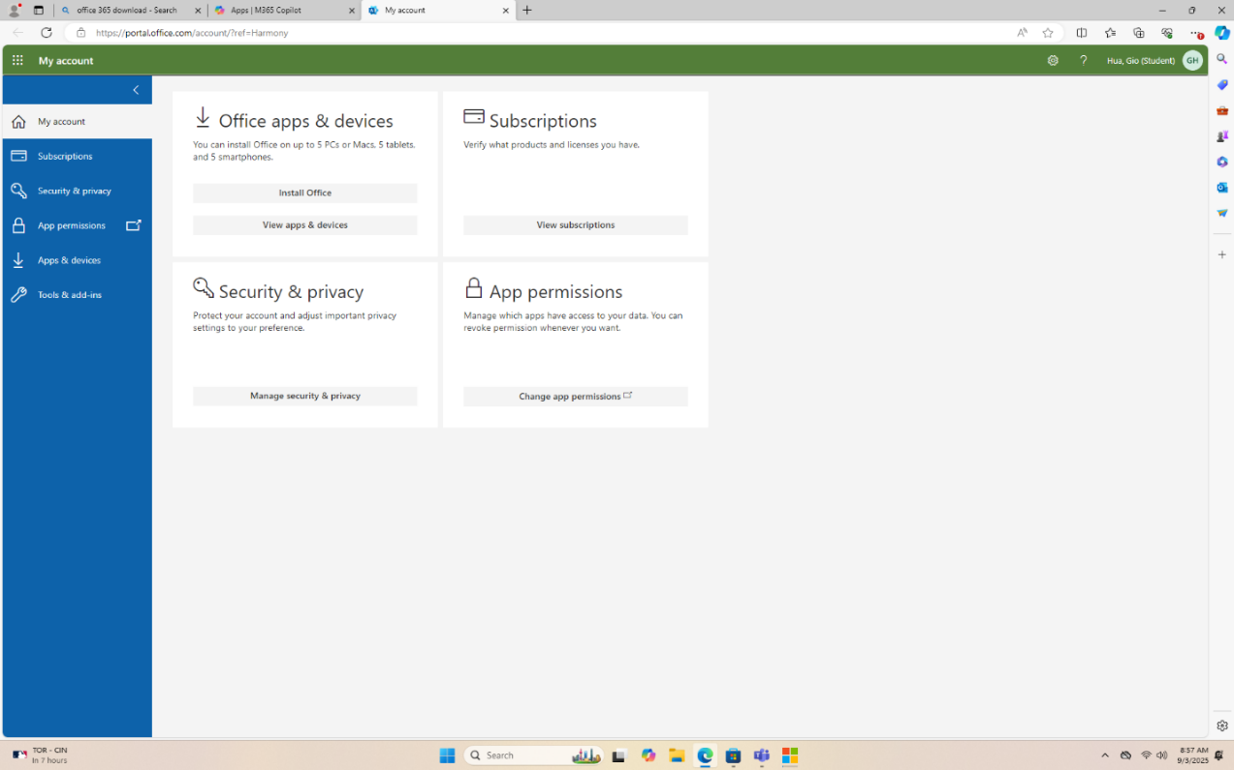
Office 365 – Downloading Applications
Step 1: Search up Office 365 on the web
Step 2: Sign into your account
Step 3: Go the My account
Step 4: Click Install Office

Problems: Could not sign into Teams, as the device was not enrolled
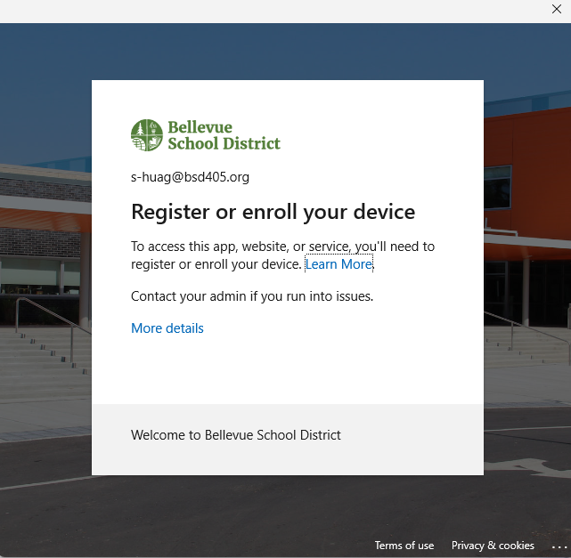
Solution: Go to Settings. Click Accounts then Access work or school. Sign into account
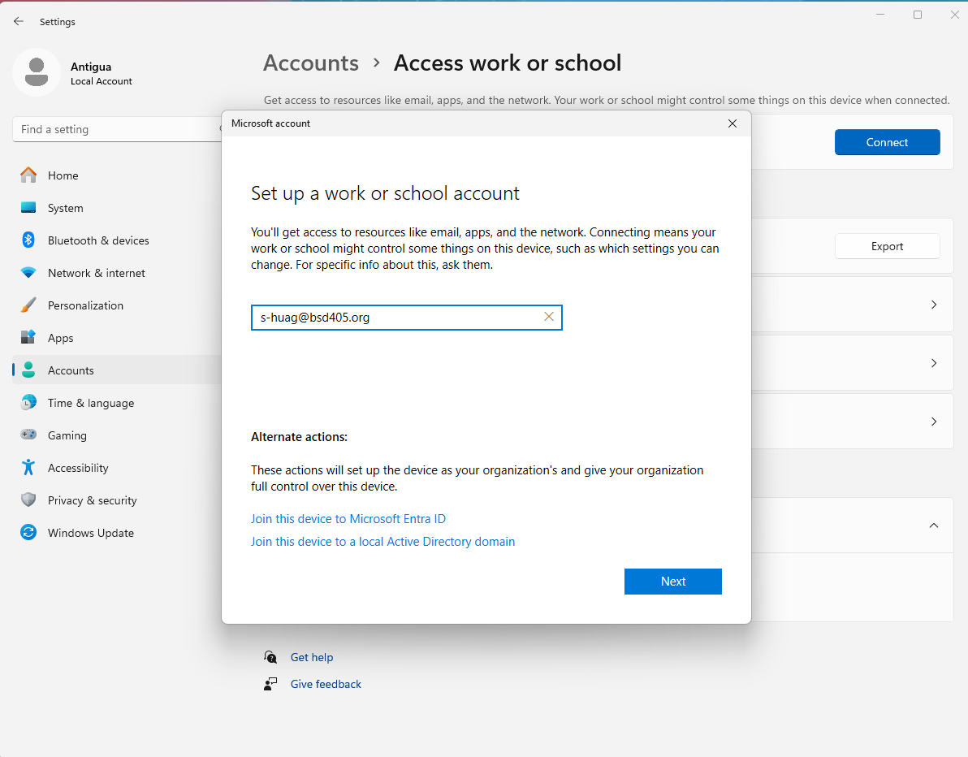

Conclusion: Learned how to install an OS, specifically Windows 11. Solved problems such as account access. Additionally, learned where and how to install drivers and updates.

